Assignment 1

#Qs1)

num=input("Enter a number ")

Digits=list(num)

Sum=int(Digits[0])\*\*3+int(Digits[1])\*\*3+int(Digits[2])\*\*3

if int(num)==Sum:

print(num,"is an armstrong number")

else:

print(num,"is not an armstrong number")

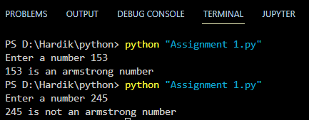

#Qs2)

nationality=input("Enter your nationality ")

if nationality=="India":

state=input("Enter your state ")

if state=="Pune":

print("You are on the waitlist for hostel accomodation")

else:

print("You are eligible for hostel accomodation")

else:

print("Please visit the International office")

